**Department of (Department Name)**

**Pak-Austria Fachhochschule: Institute of Applied Sciences and Technology, Haripur, Pakistan**

**COMP-261L Computer Organization & Assembly Language Lab**

**Lab Report: 03**

**Class: BS Computer Science**

**Name: Ahmed Raza**

**Registration No.: B20F0436CS031**

**Semester: 3rd**

**Submission Date: 21 Oct, 2021**

**Submitted to: Lab Engr. Rafi Ullah**

**__________________**

**Instructor Signature**

**Lab No. 3**

**Arithmetic Instructions**

**Objectives:**

After completing this lab, you should be able to:

* Understand the working Arithmetic instruction
* Understand the use the Arithmetic Instruction by Implementing them.

**Tools/Software Required:**

**EMU8086 Software**

**Introduction:**

Introduction to Assembly language and its syntax and try following instructions.

1. ADD Instruction
2. ADC Instruction
3. SUB Instruction
4. SBB Instruction
5. INC Instruction
6. DEC Instruction
7. NEG Instruction
8. MUL Instruction
9. DIV Instruction

**Lab Tasks:**

**Lab Task 01:**

Write an assembly program that loads AX, BX, CX and DX registers with 1254, B812, 9067, ADC3 and adds AX, BX, CX and DX. Save the sum in DI register.

**Code:**

.model small

.stack 100h

.code

main proc

mov ax,1254h

mov bx,0b812h

mov cx,9067h

mov dx,0adc3h

add ax,bx

add cx,dx

add ax,cx

mov di,ax

main endp

end main

**Output:**

**Lab Task 02:**

Write an assembly language program that find the square of a number existing in AH. Result must be stored in DX register

**Code:**

.model small

.stack 100h

.code

main proc

mov bl,7h

mov bh,7h

mov al,bl

mov ah,bh

mul ah

mov bh,ah

mov al,.5

mul al

main endp

endp main

**Output:**

**Lab Task 03:**

Write an assembly language program that divides the number in BL by the number in CL and then multiplies the result by 2. The final answer must be a 16-bit number stored in the DX register.

**Code:**

.model small

.stack 100h

.code

main proc

mov bl,10

mov ax,bx

mov cl,5

div cl

mov cx,2

MUL cx

mov dx,ax

main endp

endp main

**Output:**

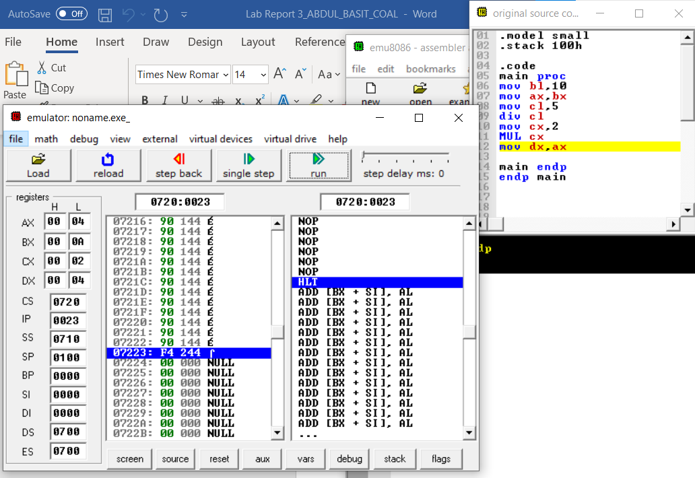

**Results & Observations:**

In this lab we learn about arithmetic instruction and by implementing them. FollowinginstructionADD,ADC,SUB,SBB,INC,DEC,NEG,MUL,DIV were learned byus. In Divide instruction dividend store in higher bit for example divisor store in 8 bit and dividend store in 16 bit. sO at the end we get full result by practicing on many problems and get our required answer.